[Bot Library](https://test.autobot.live/botlibrary) [Pricing](https://test.autobot.live/#pricing) [Documentation](https://test.autobot.live/docs) Resources Partner Central Dashboard

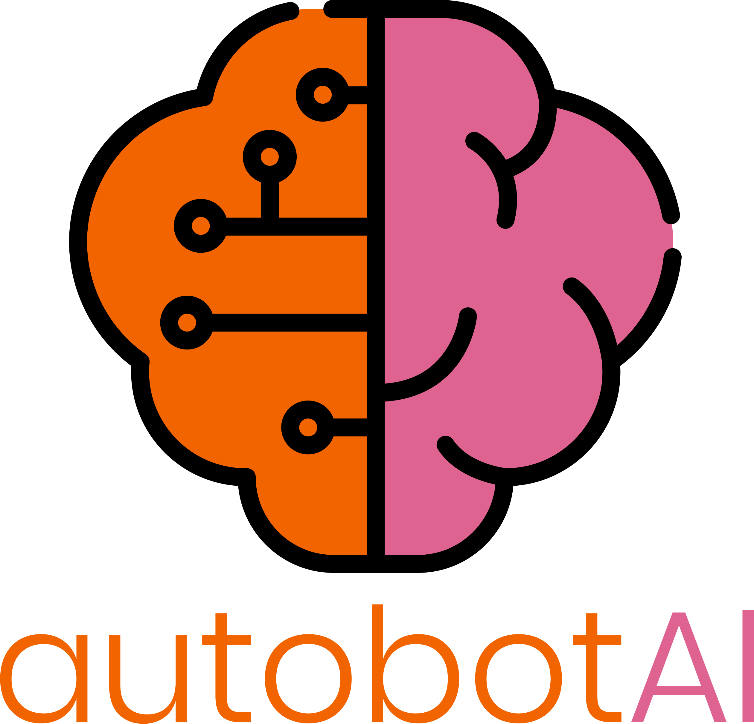

[Bot Library](https://test.autobot.live/botlibrary) [Pricing](https://test.autobot.live/#pricing) [Documentation](https://test.autobot.live/docs) Resources Partner Central

Hyperautomation adoption

**Cloud Security and Operational excellence**



[Bot Library](https://test.autobot.live/botlibrary) [Pricing](https://test.autobot.live/#pricing) [Documentation](https://test.autobot.live/docs) Resources Partner Central

## ABSTRACT

In an era where digital transformation is paramount, hyperautomation emerges as a critical catalyst, especially within the realms of cloud and security operations. This white paper delves into the concept of hyperautomation, propelled by advanced technologies such as Generative AI with Robotic Process Automation related to Cloud and security operations for AIOps to automate processes beyond traditional capabilities. Guided by Gartner's insights and predictions, we explore how hyperautomation acts as an indispensable enabler for enhancing security, operational efficiency, and cost optimization in cloud environments. Through autobotAI’s innovative platform, we illustrate the practical application and transformative potential of hyperautomation, underscoring its significance in navigating the complexities of today's digital landscape.

[Bot Library](https://test.autobot.live/botlibrary) [Pricing](https://test.autobot.live/#pricing) [Documentation](https://test.autobot.live/docs) Resources Partner Central

## INTRODUCTION



The rapid acceleration of digital initiatives across various industries has underscored the critical need for advanced automation solutions. These solutions are pivotal in navigating the complex challenges associated with cloud operations and security. Hyperautomation stands at the confluence of multiple technological evolutions, aiming to automate the complex decision-making and processes that standard automation tools could not address. This comprehensive approach is designed to not only augment human capabilities but also to foster a more resilient, efficient, and secure digital ecosystem. Within this evolving context, autobotAI distinguishes itself as a key player. It embodies the essence of hyperautomation, streamlining cloud operations, bolstering security measures, and driving significant cost efficiencies.

As organizations set their sights on adopting hyperautomation, it becomes imperative to outline a clear execution plan. Identifying labor-intensive or repeatable processes that will benefit managed security service providers (MSSPs), Cloud detection and response (CDR) providers, and large enterprises is crucial. This approach ensures an immediate return on investment (ROI) by eliminating the administrative overhead associated with incident response, IAM, Threat hunting, CSPM based operation. With a strategic direction in place, Adoption Leaders can then establish evaluation criteria that include key operational metrics such as mean time to respond / remediate (MTTR), or service level objectives (SLOs), alongside business metrics like profit margins. It's essential to recognize that the metrics driving the desired outcomes may extend beyond the specific areas being automated.

The successful implementation, monitoring, and assessment of hyperautomation initiatives necessitate the involvement of Adopting Teams. Comprising security experts and users, these teams are instrumental in mitigating implementation challenges and enhancing the likelihood of achieving the set goals, thereby playing a critical role in the seamless integration and effective utilization of hyperautomation within organizational frameworks.



[Bot Library](https://test.autobot.live/botlibrary) [Pricing](https://test.autobot.live/#pricing) [Documentation](https://test.autobot.live/docs) Resources Partner Central

## Gartner Impact Radar

The Gartner Emerging Tech Impact Radar: 2023 report features “Hyperautomation in

Security” as a Critical Enabler. Based on time-to-adoption, it is one of the most impactful emerging technologies and trends in 2023

Enhancements in analytics and automatic remediation capabilities will redirect 30% of IT operations efforts from support to continuous engineering through 2024.

By 2024, 40% of product and platform teams will employ AIOps for automated change risk analysis in DevOps pipelines, minimizing unplanned downtime by 20%.

Over 75% of large enterprises in mature economies will adopt container management by 2024, driven by the increasing adoption of cloud-native applications and infrastructure.

By 2025, 50% of enterprises will have implemented AI orchestration platforms to operationalize AI, a significant increase from less than 10% in 2020.



[Bot Library](https://test.autobot.live/botlibrary) [Pricing](https://test.autobot.live/#pricing) [Documentation](https://test.autobot.live/docs) Resources Partner Central

Read More

## Security Automation use cases

**Identity and access management (IAM) automation**

The IAM-based automation use cases focus on streamlining identity lifecycle processes, such as efficient onboarding/offboarding, strict contractor management, and disabling inactive accounts. They also aim to strengthen IAM posture through auditing, Just-in-Time access, and automated investigation of anomalies, alongside improving response to service requests by optimizing access approvals, simplifying self-registration , and automating permission elevation, thereby enhancing the user experience for information employees.

## CSPM, KSPM, DSPM automation

Use cases to automate remediation findings from CSPM, KSPM, and DSPM tools

leverage advanced algorithms triggering context-aware remediation workflows. For critical production environments, the system escalates issues with urgent notifications requiring human approval, ensuring that changes are reviewed thoroughly to mitigate risks. This approach ensures that security postures are

[Bot Library](https://test.autobot.live/botlibrary) [Pricing](https://test.autobot.live/#pricing) [Documentation](https://test.autobot.live/docs) Resources Partner Central

strengthened across all deployment stages, with human oversight preserved for

[critical decisions,](https://test.autobot.live/botlibrary) [thereby](https://test.autobot.live/#pricing) [optimizing the](https://test.autobot.live/docs) balance between speed and security.

**Threat intel integrated Incident response automations** Threat intelligence-integrated incident response automation streamlines the handling of security events and alerts by correlating, enriching, and prioritizing

incoming data from various sources. By integrating threat intelligence (TI) feeds, the system enhances event context, automates containment, investigation, and remediation actions, and efficiently manages block lists. Additionally, it facilitates communication and coordination with IT, developers, and business owners for comprehensive incident management. This automation not only accelerates response times but also ensures that security measures are dynamically updated based on the latest threat intelligence, significantly improving the efficiency and effectiveness of SOC operations.

## Availability based operations automation

Availability-based operations automation streamlines the process of ensuring continuous application uptime by automatically triggering a set of troubleshooting protocols upon detection of downtime. Utilizing monitoring tools for initial detection, the automated workflow promptly checks for issues such as log storage constraints and service disruptions. It then executes predefined standard operating procedures to address these problems, such as service restarts or resource reallocation. This automation significantly lightens the load on CloudOps and SecOps teams by swiftly identifying, remedying, and verifying the resolution of performance, scalability, or

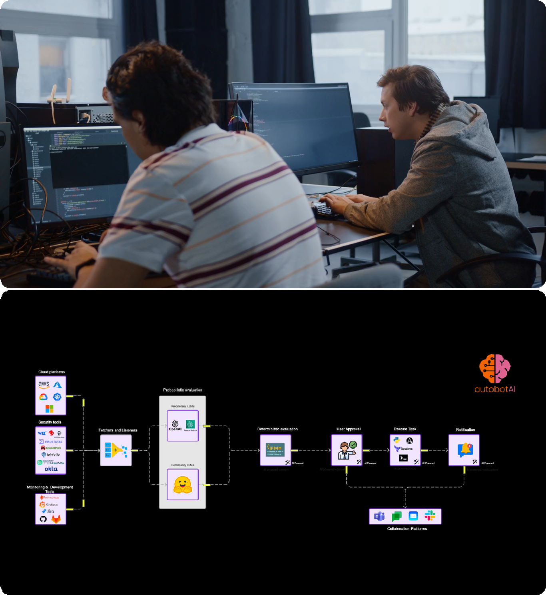

[Bot Library](https://test.autobot.live/botlibrary) [Pricing](https://test.autobot.live/#pricing) [Documentation](https://test.autobot.live/docs) Resources Partner Central

business impact issues, ensuring minimal downtime and maintaining operational

[continuity.](https://test.autobot.live/botlibrary)

Hyperautomation in security has reached a critical mass. The Gartner report considers it an enterprise investment that will have the most long-term impact and ROI. autobotAI is designed to help CloudOps and SecOps teams do task and process mining and help teams to automate security and cloud operations across platforms like AWS, Azure, GCP, and Kubernetes is critical step to scale operations with small technical expert teams. autobotAI stands out by integrating Customer's own generative AI with workspace based architecture support to provide complete data and permission sovereignty, facilitating more intuitive and context-aware automation workflows.

## Example automation use cases

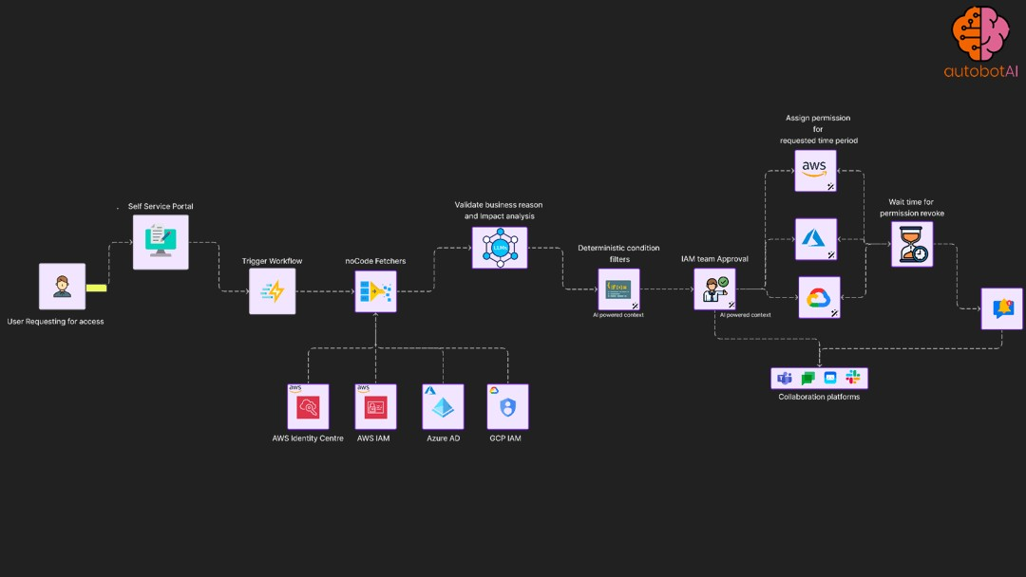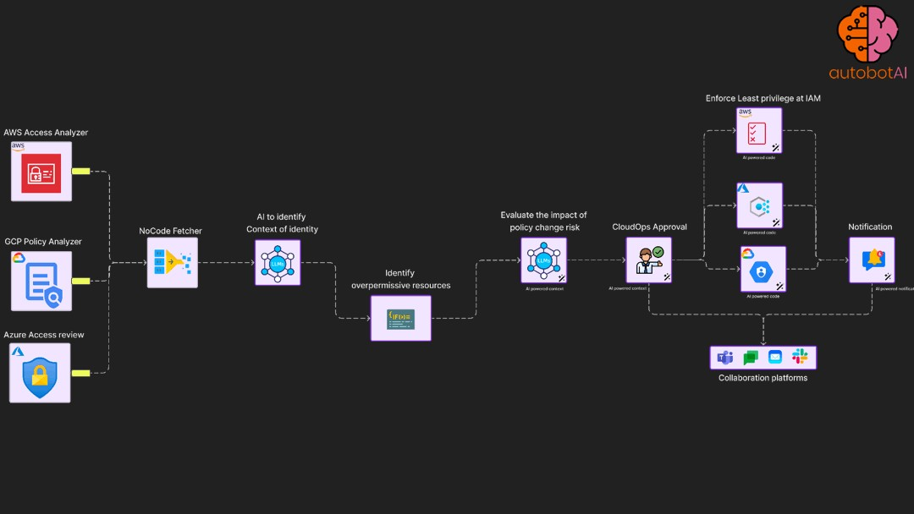

[Bot Library](https://test.autobot.live/botlibrary) [Pricing](https://test.autobot.live/#pricing) [Documentation](https://test.autobot.live/docs) Resources Partner Central

**Just in time access**

automation use case that provide self-service portal to users to trigger request based elevated access controls

## Least privilege enforcement automation

Periodically access permission utilisation for roles and apply permission boundary

## Incident response

Incident response with

Cloud native and partner's security services

integration.

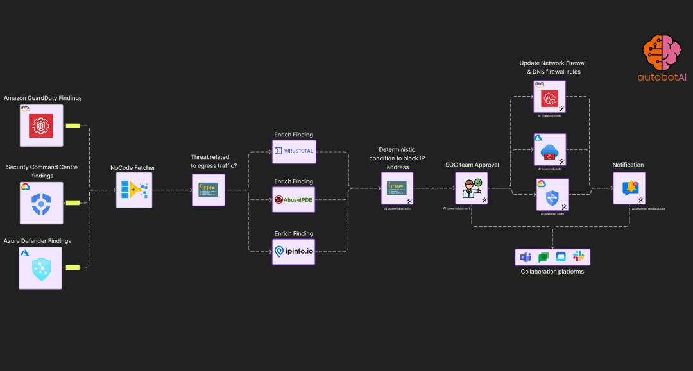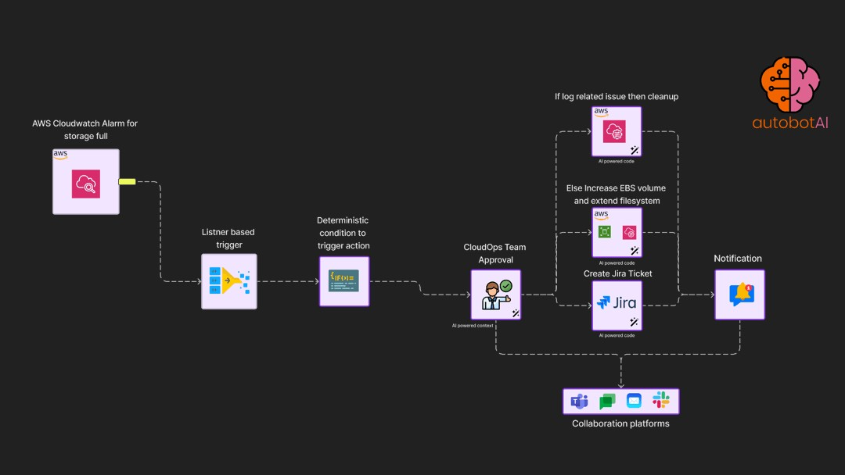

[Bot Library](https://test.autobot.live/botlibrary) [Pricing](https://test.autobot.live/#pricing) [Documentation](https://test.autobot.live/docs) Resources Partner Central

## Operational excellence for availability

Automatically detect storage availability for cloud instance and cleanup or increase space based on user approval

## Results

**Reduction of operational cost**

# 30%



[Bot Library](https://test.autobot.live/botlibrary) [Pricing](https://test.autobot.live/#pricing) [Documentation](https://test.autobot.live/docs) Resources Partner Central

[**Improved**](https://test.autobot.live/docs) **MTTR by**

# 60%

**Reduced technical debt**

# 48%

Adopting CloudOps and SecOps operations automation equips customers with the capability [to](https://test.autobot.live/botlibrary) significantly streamline [their](https://test.autobot.live/docs) operational processes, leading to notable cost

savings and enhanced efficiency. By automating the detection, troubleshooting, and

[Bot Library](https://test.autobot.live/botlibrary) [Pricing](https://test.autobot.live/#pricing) [Documentation](https://test.autobot.live/docs) Resources Partner Central

|  |  |  |
| --- | --- | --- |
| remediation of application downtimes, organizations can reduce the need for manual  intervention, allowing technical teams to focus on more strategic initiatives. This shift not only accelerates response and remediation times but also aids in systematically addressing and reducing technical debt. The automation of routine monitoring and problem-solving tasks ensures that issues are resolved swiftly and consistently, minimizing operational disruptions and contributing to a more stable, efficient IT environment. | | |
|  |  |  |
|  |  |  |

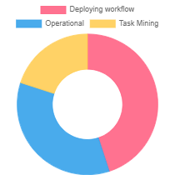

[Bot Library](https://test.autobot.live/botlibrary) [Pricing](https://test.autobot.live/#pricing) [Documentation](https://test.autobot.live/docs) Resources Partner Central

|  |  |  |
| --- | --- | --- |
|  | **Accelerate with automation experts**  AutobotAI offers a unique approach to automation, providing it as a service where our dedicated team of automation experts meticulously crafts workflow solutions tailored to your specific needs.  Read More... |  |
| autobotAI introduces a game-changing suite of integrations across security, cloud services, IAM capabilities, communication, ticketing, monitoring, and code repository management. By incorporating tools like Amazon Security Lake, Splunk, Google Directory, Microsoft Entra ID, Jira, Slack, Prometheus, Datadog, GitHub, and more, we're significantly enhancing the ability to streamline operations, fortify security, and ensure continuous compliance. These advanced integrations are designed to break down silos, providing teams with the means to achieve operational excellence and an enhanced security posture with unparalleled efficiency. | | |
|  | | |

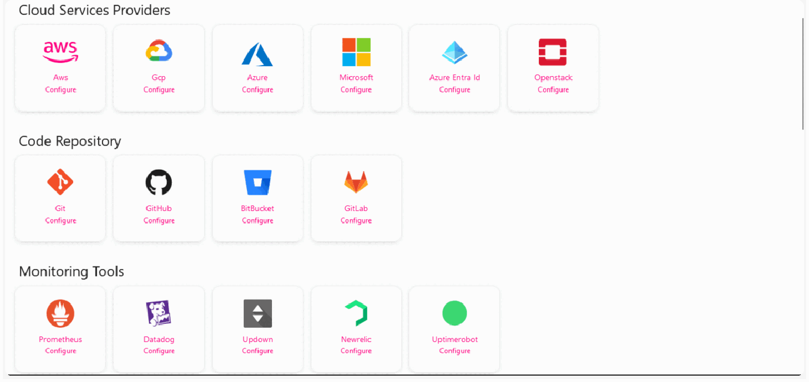

[Bot Library](https://test.autobot.live/botlibrary) [Pricing](https://test.autobot.live/#pricing) [Documentation](https://test.autobot.live/docs) Resources Partner Central

In today's fast-paced digital environment, achieving operational excellence through security automation is not just an option but a necessity. autobotAI is at the forefront of this transformative journey, offering a unique blend of expertise, technology, and support designed to help customers swiftly adopt and benefit from security automation. Here's how the autobotAI team facilitates a seamless adoption process and the advantages of partnering with us.

Personalized Consultation and Task Mining: The autobotAI team begins by working closely with customers to understand their unique challenges and requirements. Through a process of task mining, our experts identify repetitive, time-consuming tasks within your security operations that are ripe for automation. This initial step is crucial in pinpointing

where automation can make the most significant impact, setting the stage for a tailored automation strategy.

Expert-Led Development and Implementation: Drawing on our deep domain expertise in security automation, the autobotAI team crafts customized automation workflows that align with your specific operational needs and security policies. Our approach ensures that automation is not just implemented but is strategically deployed to enhance security responsiveness and efficiency.

## Advantages of Using autobotAI:

1. Rapid Deployment: With autobotAI, businesses can fast-track the implementation of security automation, thanks to our ready-to-use integrations and pre-built templates. This rapid deployment capability allows you to quickly see the benefits of automation in action.
2. Enhanced Security Posture: By automating routine security tasks, autobotAI not only frees up your security team's time but also reduces the risk of human error. Continuous monitoring, real-time threat detection, and automated remediation keep your digital assets protected around the clock.

3. Operational Efficiency: autobotAI's security automation workflows are designed to [optimize](https://test.autobot.live/botlibrary) your [security](https://test.autobot.live/#pricing) [operations,](https://test.autobot.live/docs) streamlining processes and ensuring that

resources are allocated effectively. This leads to a more agile and responsive

[Bot Library](https://test.autobot.live/botlibrary) [Pricing](https://test.autobot.live/#pricing) [Documentation](https://test.autobot.live/docs) Resources Partner Central

|  |  |  |  |
| --- | --- | --- | --- |
| security operation that can adapt to new threats and challenges as they arise.   1. Scalability: As your business grows, so do your security needs. autobotAI's flexible platform scales with you, accommodating an expanding scope of security tasks and complexity without compromising performance or reliability. 2. Insightful Analytics: With autobotAI, you gain access to actionable insights into your security operations. Our platform provides detailed analytics and reporting, helping you measure the effectiveness of your automation strategies and make data-driven decisions.   **Taking the Next Step:**  As you consider the next steps in adopting security automation, autobotAI invites you to reflect on the operational excellence of your current processes and resources. Are repetitive tasks consuming too much of your team's time? Could your security posture be stronger? If you see room for improvement, autobotAI is here to help you identify your automation use cases and guide you through the journey of transforming your security operations.  **CONCLUSIONS** | | | |
|  | | **01 Identify Automation Opportunities**  Begin with task mining to uncover and plan potential use cases for automation within your organization. This step sets the |  |
|  |  |
|  |  |  |  |



[Bot Library](https://test.autobot.live/botlibrary) [Pricing](https://test.autobot.live/#pricing) [Documentation](https://test.autobot.live/docs) Resources Partner Central

foundation for a targeted and

impactful automation strategy.

## 02 Sigh Up for autobotAI:

Configure your dedicated autobotAI workspace, integrating it with your existing tools and platforms. This centralized

workspace serves as the launchpad for all your automation workflows.

## 03 Develop Workflows with AI Support:

Utilize autobotAI's generative AI capabilities to assist in creating effective automation workflows. This step harnesses the power of AI to simplify the workflow creation process, making it more intuitive and efficient.

## 04 Refine and Optimize

**Over Time**

Measure operational excellance with custom dashboard and make adjustments as needed to align with evolving operational demands. This iterative process ensures sustained operational

excellence and maximizes the

[benefits](https://test.autobot.live/botlibrary) [of hyperautomation](https://test.autobot.live/#pricing)

[Bot Library](https://test.autobot.live/botlibrary) [Pricing](https://test.autobot.live/#pricing) [Documentation](https://test.autobot.live/docs) Resources Partner Central



Download this page with pdf

[Download](https://test.autobot.live/images/whitepaper/whitepaper.pdf)

|  |
| --- |
| [Bot Library](https://test.autobot.live/botlibrary) [Pricing](https://test.autobot.live/#pricing) [Documentation](https://test.autobot.live/docs) Resources Partner Central |



[Contact Us](mailto:hello@fusiongate.net)

We are here to help you with any queries you have.





[Contact](https://shunyeka.zohobookings.in/%23/customer/182672000000028016?booknow=true) [us](https://test.autobot.live/botlibrary)

Security & Compliance

[Bot Library](https://test.autobot.live/botlibrary) [Pricing](https://test.autobot.live/#pricing) [Documentation](https://test.autobot.live/docs) Resources Partner Central

[FAQ's](https://test.autobot.live/faqs)

[Privacy Policy](https://test.autobot.live/docs/privacy-policy) [Terms Of Use](https://test.autobot.live/docs/terms-of-use)

Copyright 2024, autobotAI. All Rights Reserved.